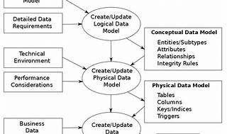

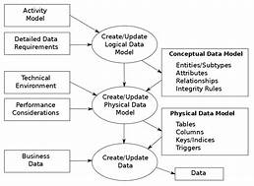

Explore

**Data modeling** is the process of creating a visual representation of data structures and relationships within a system. [It helps communicate connections between data points, types, and formats, supporting business processes and IT architecture planning1](https://www.youtube.com/watch?v=cm8UBAXwjxY)[2](https://digitaldefynd.com/best-data-modeling-courses/)[3](https://www.classcentral.com/course/edx-introduction-to-data-modeling-9910).

Here are **five free resources** where you can learn more about data modeling:

1. [**IBM’s Data Modeling Solution**: Explore data modeling concepts and best practices with IBM’s comprehensive guide1](https://www.youtube.com/watch?v=cm8UBAXwjxY).
2. [**Wikipedia’s Data Modeling Article**: Dive into the details of data modeling, its importance, and its role in organizations](https://www.youtube.com/watch?v=cm8UBAXwjxY)[2](https://digitaldefynd.com/best-data-modeling-courses/).
3. [**Microsoft Power BI’s Introduction to Data Modeling**: Learn about logical and physical data modeling, data security, and compliance](https://www.youtube.com/watch?v=cm8UBAXwjxY)[4](https://powerbi.microsoft.com/en-us/what-is-data-modeling/).
4. [**YouTube Tutorial on Data Modeling Techniques**: Discover essential techniques like Entity Relationship Diagrams (ERDs), System Context Diagrams, and Data Dictionaries1](https://www.youtube.com/watch?v=cm8UBAXwjxY).
5. [**Class Central’s Introduction to Data Modeling Course**: Understand how data models impact your organization’s data management and decision-making](https://www.youtube.com/watch?v=cm8UBAXwjxY)[3](https://www.classcentral.com/course/edx-introduction-to-data-modeling-9910).

Feel free to explore these resources to enhance your understanding of data modeling! 📊🔍